**1.Procedure to create JDBC con pool for oracle and JDBC Data Source which is placed in JNDI Registry in the Domain Server of GlassFish**

Step1: place ojdbc6/7/.. .jar file to <GlashFish_home>\domains\ ----domain\lib folder.

Step2: start the glash fish domain server

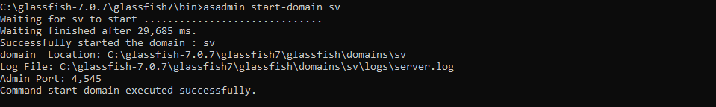

Step3: open admin page of glassFish Server

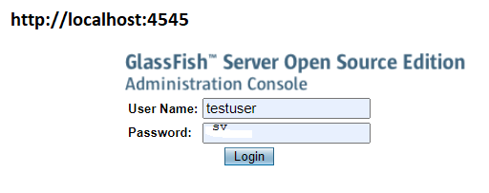

Step4: Create JDBC con pool for oracle

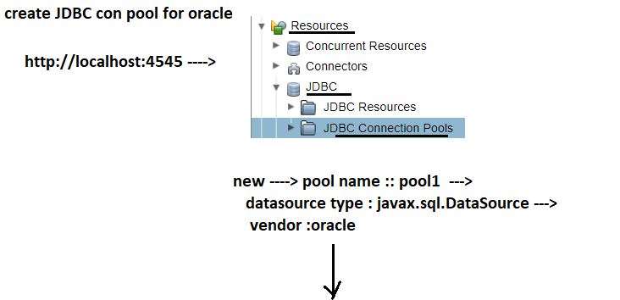

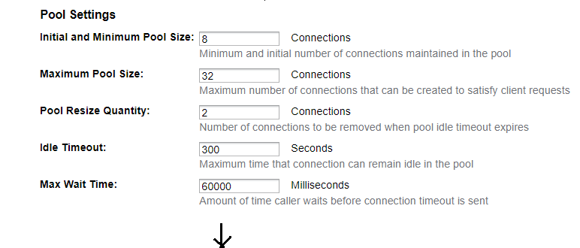

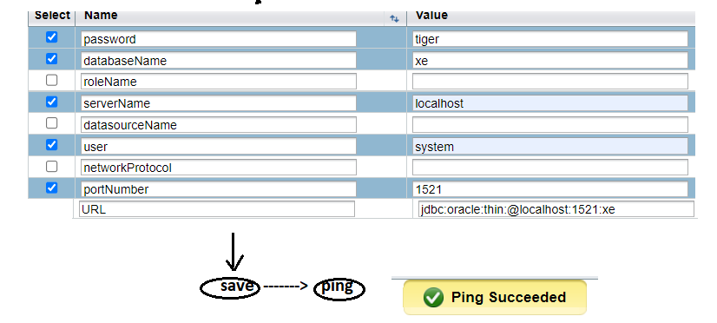

Step :5 Create DataSource object pointing to JDBC con pool and keep that Data Source object ref in JNDI registry.

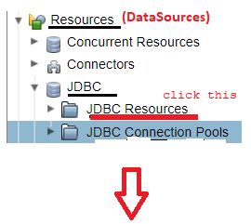

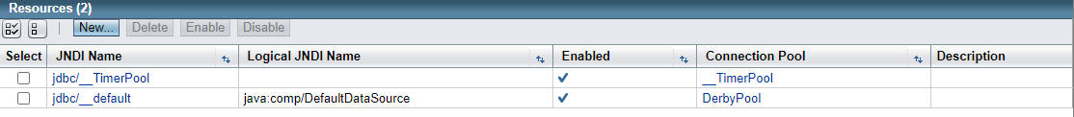



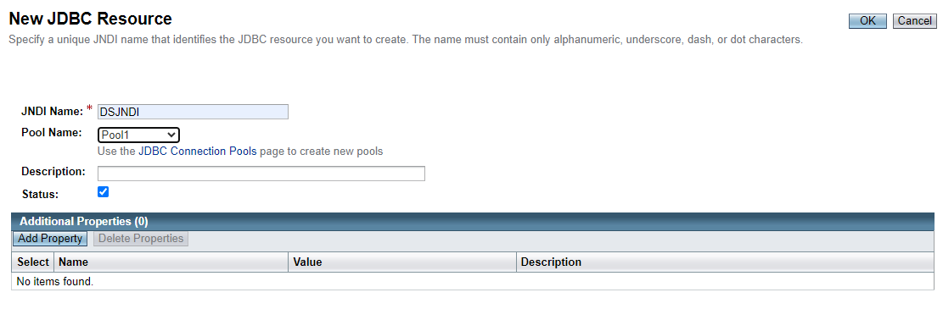



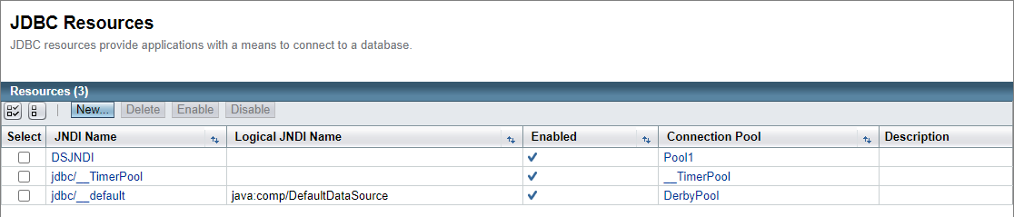



**Example:**

**=======**

Example:-

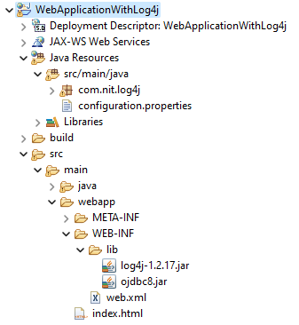

Index.html

========

<!DOCTYPE html>

<html>

<head>

<meta charset="UTF-8">

<title>Insert title here</title>

</head>

<body>

<h2 align="center">HelloWorld</h2>

<form method="get" action="./LogIn">

UserName:<input type="text" name="uname"/><br>

PassWord:<input type="password" name="pwd"/><br>

<input type="submit"/>

</form>

</body>

</html>

LogIn.java

========

**package** com.nit.log4j;

**import** java.io.IOException;

**import** java.io.PrintWriter;

**import** java.sql.Connection;

**import** java.sql.ResultSet;

**import** java.sql.SQLException;

**import** java.sql.Statement;

**import** javax.naming.InitialContext;

**import** javax.sql.DataSource;

**import** org.apache.log4j.BasicConfigurator;

**import** org.apache.log4j.Logger;

**import** org.apache.log4j.PropertyConfigurator;

**import** jakarta.servlet.ServletException;

**import** jakarta.servlet.http.HttpServlet;

**import** jakarta.servlet.http.HttpServletRequest;

**import** jakarta.servlet.http.HttpServletResponse;

**public** **class** LogIn **extends** HttpServlet {

**private** **static** **final** **long** ***serialVersionUID*** = 1L;

**public** **static** Logger *logger*;

**protected** **void** doGet(HttpServletRequest req, HttpServletResponse res) **throws** ServletException, IOException {

Connection con=**null**;

Statement s1=**null**;

ResultSet r1=**null**;

PrintWriter pw=res.getWriter();

res.setContentType("text/html");

//Class.forName("oracle.jdbc.driver.OracleDriver");

//con=DriverManager.getConnection("jdbc:oracle:thin:@localhost:1521:orcl","hms","tiger");

**try** {

InitialContext ic=**new** InitialContext();

DataSource ds=(DataSource)ic.lookup("DSJNDI");

con=ds.getConnection();

**if**(con!=**null**) {

s1=con.createStatement();

}

**if**(s1!=**null**)

r1=s1.executeQuery("Select * from person");

**if**(r1!=**null**)

{

**while**(r1.next()) {

pw.write("<h3>"+r1.getInt(1)+"</h3>"+" "+"<h3>"+r1.getString(2)+"</h3>");

}

}

}

**catch**(SQLException e)

{

System.***out***.println(e.getMessage());

}

**catch**(Exception e)

{

System.***out***.println(e.getMessage());

}

**finally** {

**try** {

r1.close();

s1.close();

con.close();

} **catch** (SQLException e) {

e.getMessage();

}

}

}

}

**Execution steps:**

**Step1: prepare the war file for web application.**

**Step2:** start the domain glashfish server.

Step3: Deploy the web application

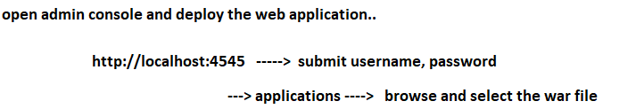

Deply the web application.

Step4:Test the web application.

**2.Procedure to create JDBC con pool for oracle and JDBC Data Source which is placed in JNDI Registry in Tomcat Server**

Step1: make sure that tomcat 10.x server is configured with eclipse ide.

Step2: place the following <resource> tag in context.xml file of Tomcat Server in the server section of Project Explorer in Eclipse IDE.

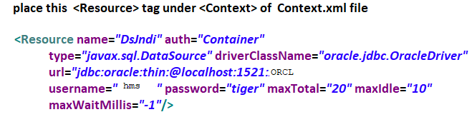

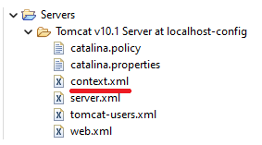

Step:3 Restart the Tomcat server.

**Note:-**

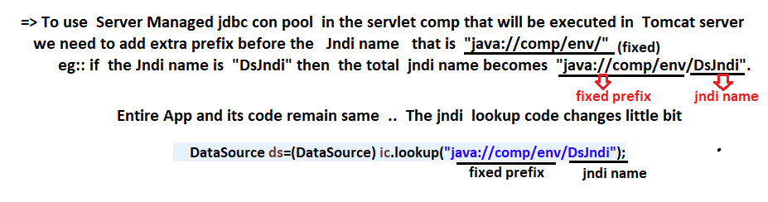

Example:-



Index.html

========

<!DOCTYPE html>

<html>

<head>

<meta charset="UTF-8">

<title>Insert title here</title>

</head>

<body>

<h2 align="center">HelloWorld</h2>

<form method="get" action="./LogIn">

UserName:<input type="text" name="uname"/><br>

PassWord:<input type="password" name="pwd"/><br>

<input type="submit"/>

</form>

</body>

</html>

LogIn.java

========

**package** com.nit.log4j;

**import** java.io.IOException;

**import** java.io.PrintWriter;

**import** java.sql.Connection;

**import** java.sql.ResultSet;

**import** java.sql.SQLException;

**import** java.sql.Statement;

**import** javax.naming.InitialContext;

**import** javax.sql.DataSource;

**import** org.apache.log4j.BasicConfigurator;

**import** org.apache.log4j.Logger;

**import** org.apache.log4j.PropertyConfigurator;

**import** jakarta.servlet.ServletException;

**import** jakarta.servlet.http.HttpServlet;

**import** jakarta.servlet.http.HttpServletRequest;

**import** jakarta.servlet.http.HttpServletResponse;

**public** **class** LogIn **extends** HttpServlet {

**private** **static** **final** **long** ***serialVersionUID*** = 1L;

**public** **static** Logger *logger*;

**protected** **void** doGet(HttpServletRequest req, HttpServletResponse res) **throws** ServletException, IOException {

Connection con=**null**;

Statement s1=**null**;

ResultSet r1=**null**;

PrintWriter pw=res.getWriter();

res.setContentType("text/html");

//Class.forName("oracle.jdbc.driver.OracleDriver");

//con=DriverManager.getConnection("jdbc:oracle:thin:@localhost:1521:orcl","hms","tiger");

**try** {

InitialContext ic=**new** InitialContext();

DataSource ds=(DataSource)ic.lookup("java://comp/env/DSJndi");

con=ds.getConnection();

**if**(con!=**null**) {

s1=con.createStatement();

}

**if**(s1!=**null**)

r1=s1.executeQuery("Select * from person");

**if**(r1!=**null**)

{

**while**(r1.next()) {

pw.write("<h3>"+r1.getInt(1)+"</h3>"+" "+"<h3>"+r1.getString(2)+"</h3>");

}

}

}

**catch**(SQLException e)

{

System.***out***.println(e.getMessage());

}

**catch**(Exception e)

{

System.***out***.println(e.getMessage());

}

**finally** {

**try** {

r1.close();

s1.close();

con.close();

} **catch** (SQLException e) {

e.getMessage();

}

}

}

}

OutPut:

=====

